Lab: PMML in DSX

January 15th, 2018

Author: Elena Lowery elowery@us.ibm.com
Table of contents
Contents
Overview 1
Required software, access, and files 1
Part 1: Load and Deploy PMML model 1

Overview
In this lab you will learn how to import PMML files into DSX and configure them for scoring.

Required software, access, and files
- To complete this lab, you will need access to a DSX Local cluster.
- You will also need to download and unzip this GitHub repository: https://github.com/elenalowery/DSX_Local_Workshop

Part 1: Load and Deploy PMML model

- Navigate to the DSX_Local_Workshop project that you imported during one of the previous labs (your project name may be different).

- Switch to the Assets tab. Scroll to Models and click add model. Select From File. Provide model name and select model type PMML.

- Click Browse. Navigate to the PMML/PMML files folder of the unzipped GitHub repository and select SPSS_ResponseChannel.xml. Click Create.

Note: this PMML file was generated from a model created in SPSS Modeler. It predicts the recommended marketing channel (direct mail, mobile, e-mail) for a customer.

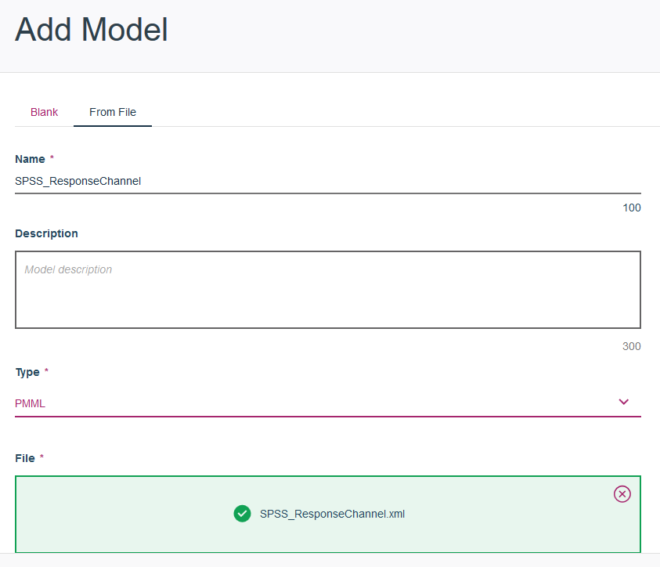
- Click the Publish tab.

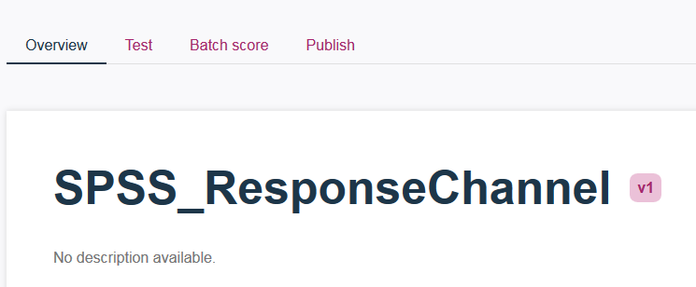

Provide Published name (make it unique, for example, add your initials) and select the scope for the project (you can publish to the same project as the model). Click Publish.

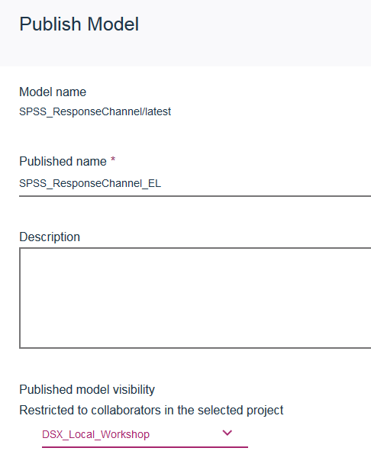

Note: If Publish throws an error, then navigate to Project Details, scroll down to Models and select Publish next to the imported PMML.

- Switch to Model Management view (from the main menu in the top left corner) and select the Models tab. Click on the model to bring up the model details view.

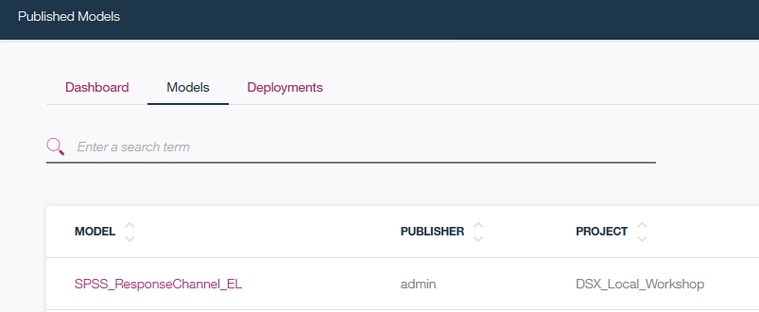

- In the model details view, scroll down and click Deploy. Provide deployment name (make it unique) and click Create.

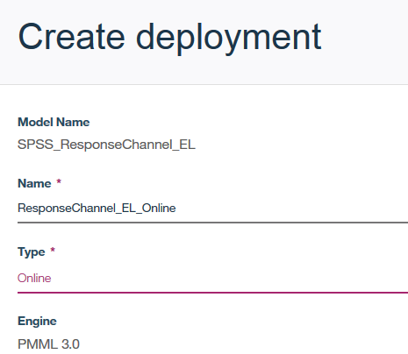

- The endpoint URL can be used by other applications to invoke scoring.

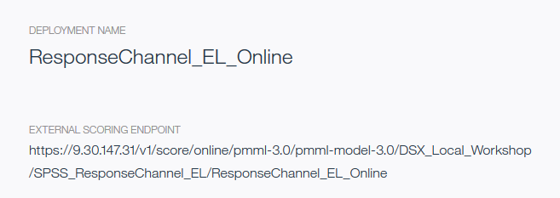

- Next, we will test the model with a notebook. Navigate to the Projects view and open the PMMLTestClient.ipynb notebook.

Note: if you would like to use the Test UI, you can use the following values (don’t provide quotes for the strings).

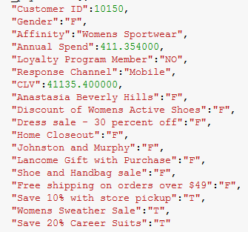

- While we went through the Publish/Deploy process, in the notebook we are using the “internal endpoint” which doesn’t require authentication. We provided this example because it’s easier to set up in a demo.

The prediction for the provided values is “Mobile” channel.

If you wish, you can change input data to the following:

12582,"M","Mens Sportswear",256.014000,"NO","Email",25601.400000,"T","T","F","F","F","F","T","T","F","T","F"

Then the prediction is to contact the customer via direct mail.

You have finished PMML in DSX Local lab.

